Competitive Shooters of Lake Norman USPSA November 18th, 2025
COURSE DESIGNER: Ike Starnes
START POSITION: See written stage briefings.
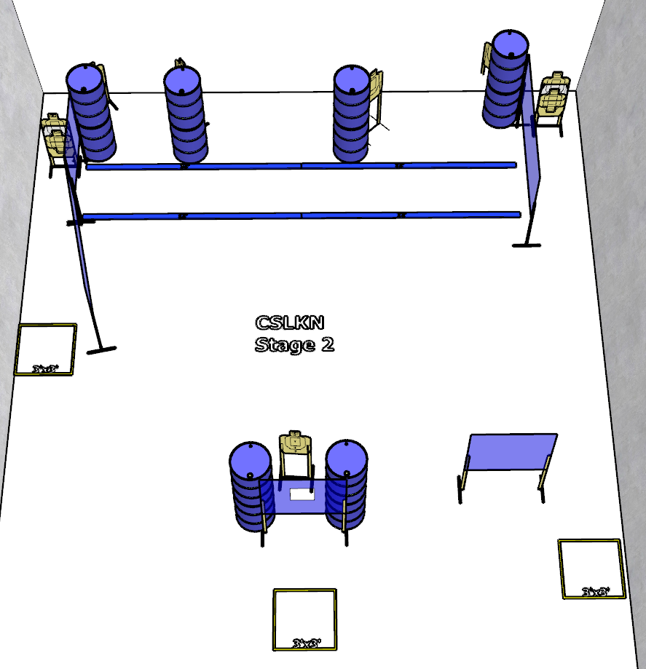

Written Stage Briefing:

Stage 2 – I believe you did sell your soul to The Devil! - is an 18-round, 90 point, Comstock Course. There are 9 cardboard targets and some no shoots. The best 2 hits per cardboard target will be scored.
Handgun start position Anywhere. The handgun is loaded and holstered.
PCC start position Anywhere. PCC is loaded with stock touching belt.
On the audible start signal, engage targets from within the shooting area.

